Name : Sundara Moorthy
Reg No : 192324228
Course code : Cloud Computing And Big Data Analysis
Exp No : EXPERIMENT 14
Date : 23/12/2025

14. Creation of a Virtual Hard Disk using VMware Workstation
Aim
To create and allocate a virtual hard disk for a Virtual Machine using VMware Workstation.
Steps
- Select the Virtual Machine in VMware Workstation.
- Click Edit Virtual Machine Settings.
- Click Add → Select Hard Disk → Click Next.
- Choose SCSI as the disk type.
- Select Create a new virtual disk.
- Specify disk size (e.g., 15 GB).
- Choose Store virtual disk as a single file.
- Click Finish and apply settings.
Output
• Virtual Hard Disk successfully created.
• Storage space allocated to the Virtual Machine.
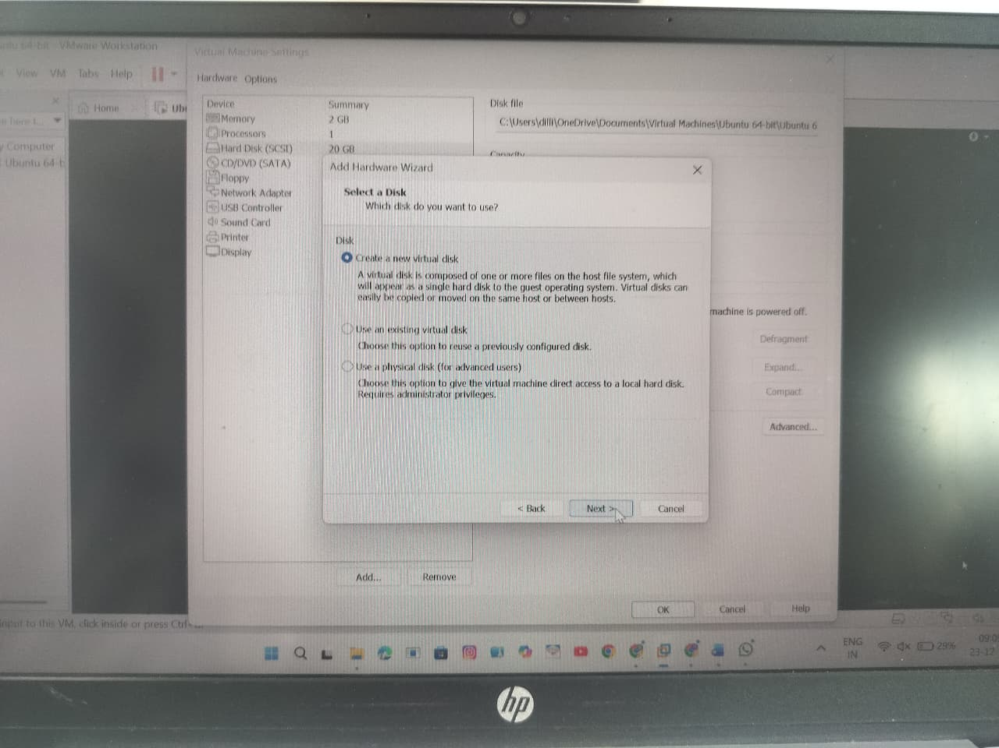

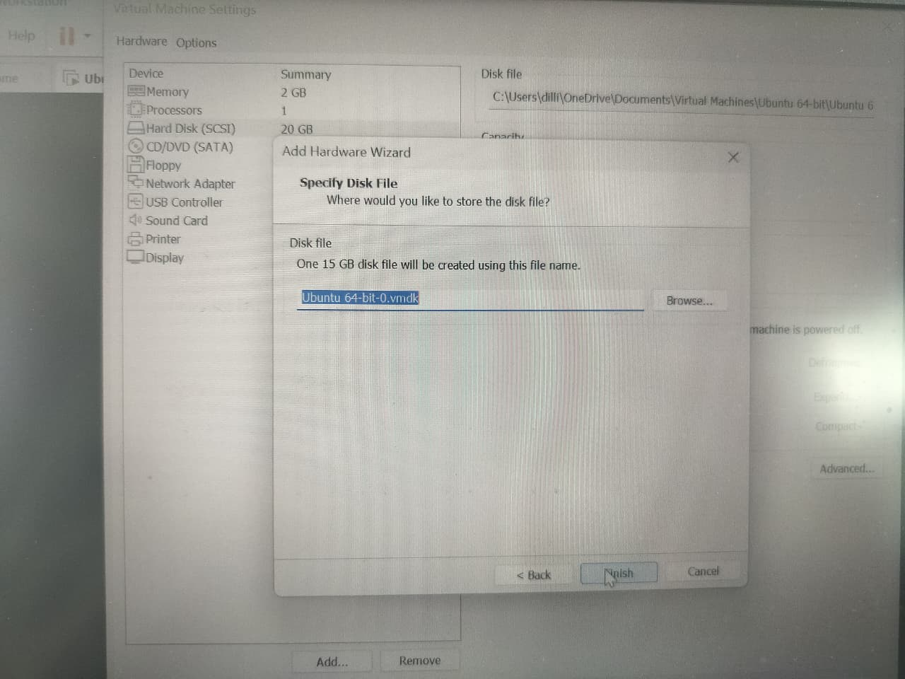

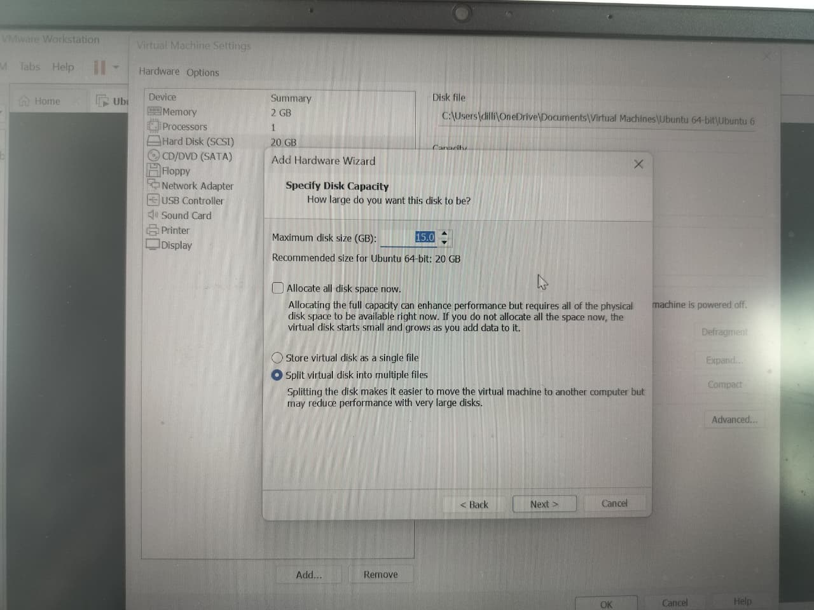
Result
Thus, a virtual hard disk was successfully created and allocated using VMware Workstation.

